CMPT 371- Lab 2

Name: Zhixin Huang

ID: 301326521

1. There are 4 fields, which are Source Port, Destination Port, Length and Checksum.
2. The length of each of the UDP header fields is 2 bytes
3. The value in the Length field (57 bytes) is the length of data (49 bytes) plus length of header (4\* 2 = 8 bytes).
4. The maximum number of bytes that can be included in a UDP payload is 2^16 - 1 - 8 = 65527 bytes.
5. The largest possible source port number is 2^16 – 1 = 65535
6. The protocol number for UDP is 11 in hexadecimal and 17 in decimal.
7. 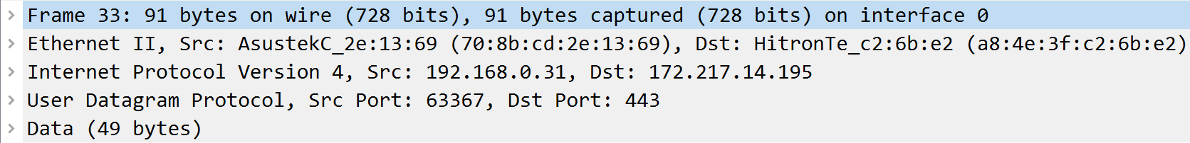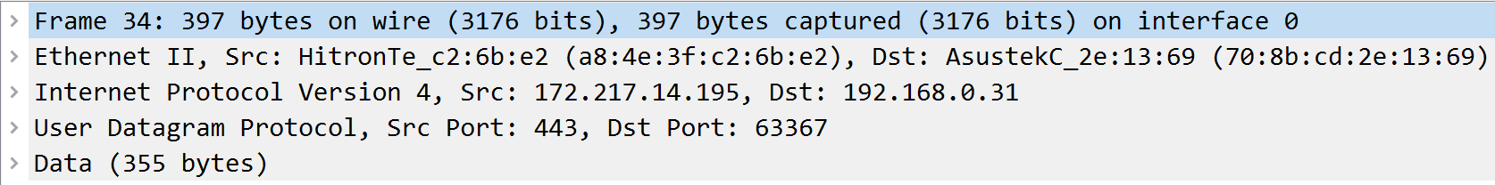

The source port number of the first packet is the same as the destination port number of the second packet, and the destination port number of the first packet is the same as the source port number of the second packet.